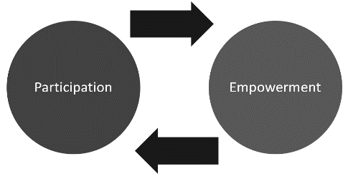

**Social Marketing**

The use of marketing techniques to promote health ideals.

Aims to change individuals’ beliefs, values and attitudes.

4 P’s:

1. Product.
2. Place.
3. Promotion.
4. Price.

**Health Products & Services**

Factors influencing usage of health products and services:

1. Media.
2. Transport.
3. Cost.
4. Consumer confidence.

Note: Product placement.

**Empowerment & Participation**

Increasing the spiritual, political, economic and social growth of individuals and communities.

Often involves the empowered developing confidence in their own capacities.

Empowerment occurs when people realise they can contribute/solve problems and have a right and responsibility to do so.

Empowerment enables people to gain control over their lives, moving from inactive non-participants to active and effective citizens.

Levels of participation:

1. Information.
2. Consultation.
3. Deciding together.
4. Acting together.
5. Supporting community interest.

**Jakarta Declaration**

Priorities:

1. Promote social responsibility for health.
2. Increase investment for health development.
3. Increase community capacity and empower the individual.
4. Consolidate and expand partnerships for health.
5. Secure an infrastructure for health promotion.

Social marketing: The ethical and moral obligation corporations, businesses, government and citizens have to larger society.

**Community Development**

A structured intervention that gives individuals greater control over their lives.

Aims to address the issues of disadvantage and powerlessness.

Involves all members of society as part of social change.

Principles:

1. Sustainability.
2. Diversity.
3. Social justice.
4. Human rights.
5. Addressing disadvantage.
6. Valuing local knowledge.

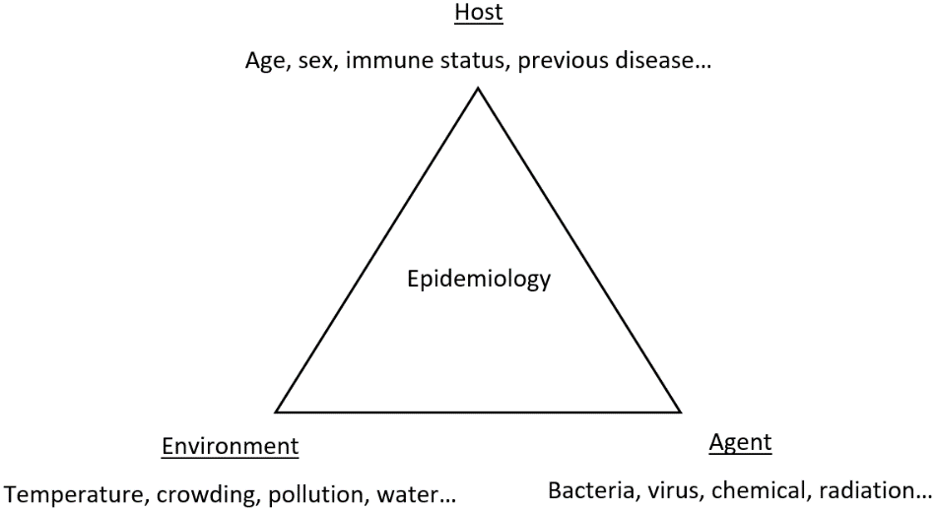

Epidemiologists:

1. Count cases of disease or injury.
2. Define the affected population.
3. Compare these rates with those found in other populations.
4. Make inferences regarding the patterns of disease to determine whether a problem exists or is likely to exist in the future.

**Preventive Strategies**

* Screening.
* Immunisation.
* Health education.
* Memory cells.

Levels of prevention:

1. Primary prevention.
2. Secondary prevention.
3. Tertiary prevention.

Epidemiologists typically ask:

* Which individuals have experiences the event?
* When did they experience the event?
* Where are the individuals who have experienced the event?
* What environmental factors are associated with the event?

**Epidemiology**

The study of the distribution and determinants of health-related conditions in specified populations, and the application of this study to control health problems.

Measures:

1. Mortality.
2. Morbidity.
3. Incidence of disease.
4. Life expectancy.
5. Prevalence of disease.
6. Burden of disease.

Role:

* Information is used to predict life expectancies and disease outbreaks as well as to advise and inform health promotion.
* Provides the basis for disease prevention globally.
* Concerned with the study of health-related events in a population.

Epidemiologists:

1. Count cases of disease or injury.
2. Define the affected population.
3. Compare these rates with those found in other populations.
4. Make inferences regarding the patterns of disease to determine whether a problem exists or is likely to exist in the future.

Questions:

* Which individuals have experiences the event?
* When did they experience the event?
* Where are the individuals who have experienced the event?
* What environmental factors are associated with the event?